**______________________________________________________________**

**Lab 5:** Ethical Foundations – Responsible AI Coding Practices  
**Lab Objectives:**• To explore the ethical risks associated with AI-generated code.  
**Week3 -  
Monday**

• To recognize issues related to security, bias, transparency, and  
copyright.  
• To reflect on the responsibilities of developers when using AI  
tools in software development.  
• To promote awareness of best practices for responsible and  
ethical AI coding.  
**Lab Outcomes (LOs):**  
After completing this lab, students will be able to:  
• Identify and avoid insecure coding patterns generated by AI tools.  
• Detect and analyze potential bias or discriminatory logic in AI-  
generated outputs.  
• Evaluate originality and licensing concerns in reused AI-  
generated code.  
• Understand the importance of explainability and transparency in  
AI-assisted programming.  
• Reflect on accountability and the human role in ethical AI coding  
practice

**Task Description #1 (Privacy in API Usage):**

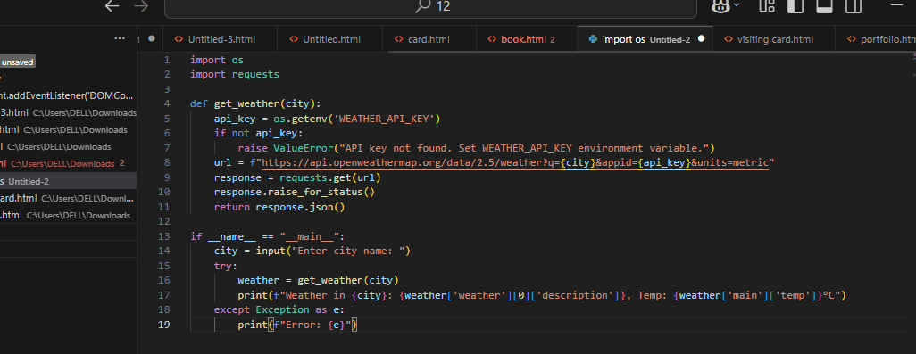

**Expected Output**:  
• Original AI code (check if keys are hardcoded).  
• Secure version using environment variables.

**Task Description #2**

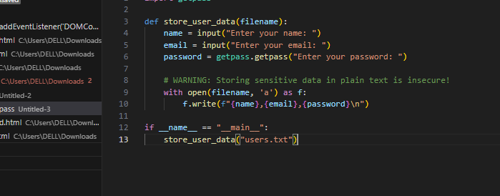

**Expected Output:**• Identified privacy risks.  
• Revised version with encrypted password storage (e.g., hashing).

**Task Description #3**

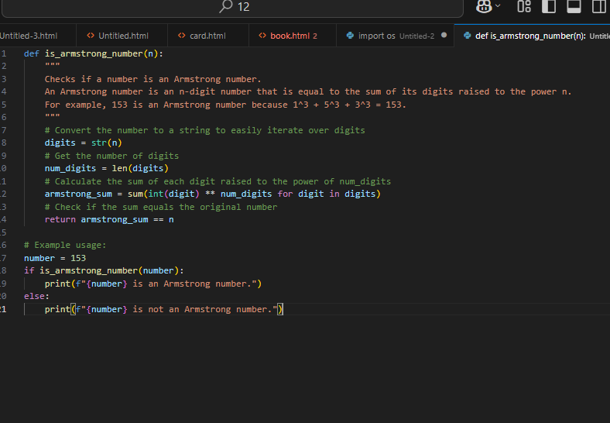

**Expected Output:**• Transparent, commented code.  
• Correct, easy-to-understand explanation

**Task Description #4**

